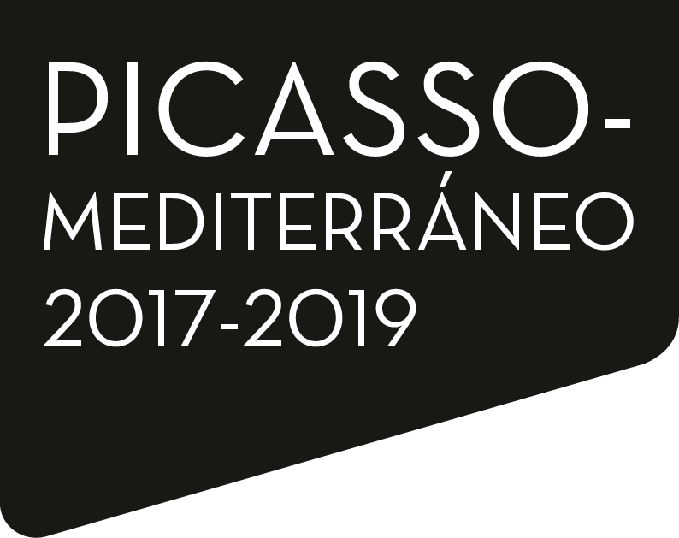

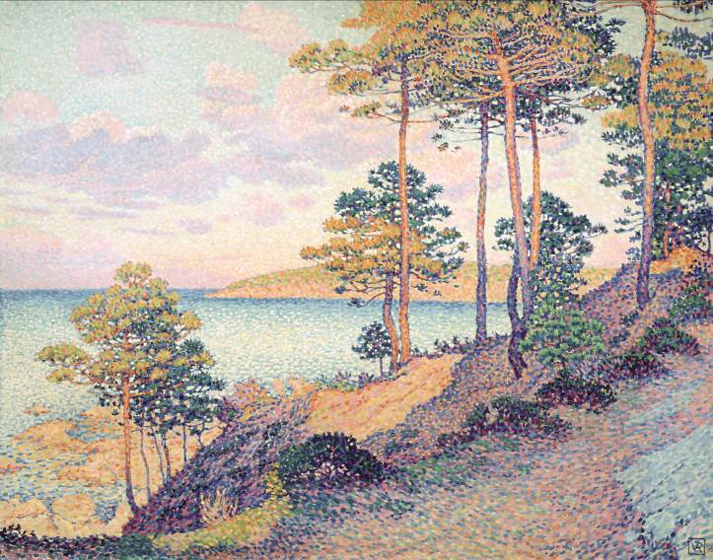
From October 10th to January 13th 2019
Fundación MAPFRE Recoletos Exhibition Hall

Fundación MAPFRE is delighted to invite you to the press conference that will be held on October 5th at 10:30 am at Fundación MAPFRE’s Auditorium located in Paseo Recoletos 23, Madrid on the occasion of the opening of the exhibition: Rediscovering the Mediterranean.
The curators, Ms. Marie-Paule Vial, former Director of the Marseille Museum and the Musée National de l’Orangerie and Mr. Pablo Jiménez Burillo, Head of the Culture Area of Fundación MAPFRE will participate in the presentation of the show.

Press Conference: October 5th 10:30 am
Dates: From October 10th 2018 to January 13th 2019
Venue: Fundación MAPFRE Recoletos exhibition hall (Paseo Recoletos 23, Madrid)
Curator: Ms. Marie-Paule Vial, former Director of the Marseille Museum and the Musée National de L’Orangerie.
Mr. Pablo Jiménez Burillo, Director of the Culture Area of Fundación MAPFRE.
Production: Fundación MAPFRE

Corporate Communications Management
Alejandra Fernández Martínez
Tel. 91 581 84 64 – 690 049 112
alejandra@fundacionmapfre.org

REDISCOVERING THE MEDITERRANEAN____________________________________________
INTRODUCTION
Along with more shocking, combative or radical works, the birth of modern art also included, as one of its great references, the rediscovery of the Mediterranean, a way through which it seemed to find a moment of energy and at the same time of tranquility, of equilibrium between the old and the modern, between the city and nature, producing one of the most brilliant eras in painting during the transition from the 19th to the 20th century.
The exhibition aims to chart a path through a style of painting that, with its own distinct peculiarities, established the Mediterranean as the catalyst for artistic renewal during said period. This new style was a way to reconcile the past with an ever-changing present, full of contradictions, in the name of a classicism that is inscribed by its own right within modernity. In one way or another, artists present in this exhibition adopted the Mediterranean, its waters and its culture as one of the main motifs in their compositions denoting a decisive moment in the evolution of art and basking in fleeting instants of harmony and beauty in the often tormented history of contemporary art.
Following this discourse the show opens with Spain, where the Mediterranean coast is, sometimes, simply a natural space that hosts local artists in their outings to paint in the open air. A place for work but also, and above all else, for pleasure, for bathing, children playing and running through the beach: this is the case of the paintings by Joaquín Sorolla, Cecilio Pla or Ignacio Pinazo. Nevertheless, being born in the Mediterranean also seemed to grant marked traits in identity. It was understood in this way, in Catalonia, by the Noucentisme movement spearheaded by artists such as Joaquín Torres- García and Joaquim Sunyer, who managed to create a vision and a national image based on calm and balanced landscapes, based on a simple and natural way of life inherent to an immutable antiquity.
The vision of this idealized world in the works of Catalan artists such as Joquim Mir or Hermen Anglada Camarasa during his stays in Mallorca is instead closer to that of French painters. The island becomes a symbol of the Arcadia the artists are yearning for and also becomes a space in which to experiment with pure colors, in which to be seduced by the wilderness and exuberant nature, in which to search for the bright light that reveals the richest hues, the most evocative contrasts. It is something the viewer can appreciate in the section that presents France. The experience Monet encounters upon his arrival in Bordighera, as well as Signac in Saint-Tropez or Derain in L’Estaque. The same experience that can be perceived in pre-Cubist Braque or in Renoir’s work in Les Collettes or Pierre Bonnard’s in Le Cannet.
For the Italians, who comprise the following section in the exhibition, the Mediterranean appears to be more of an idea, a concept that governs the manner in which the artists painted. Whatever the subject, the Mediterranean becomes a re-encounter with classicism and their own roots which seems to guide the hands of artists such as Giorgio de Chirico, Carlo Carrà or Massimo Campigli.

REDISCOVERING THE MEDITERRANEAN____________________________________________
The work of both Matisse and Picasso, which brings the exhibition to a close, incorporates aspects similar to those in the works of the aforementioned artists, as if with them the Mediterranean motif were to reach its culmination. On the one hand the viewer encounters the placidness that is conveyed by Matisse’s compositions with his taste for painting and for life, and on the other, the ambivalence in the works of Picasso: some of which are narrative in their nature, but also classic and primitive at times, and which exhibit all the aggressiveness and melancholy that exist in life, that exist within the artist. While Matisse celebrates Nature, Picasso seems unable to find peace and alternates styles in his search of the joy of painting, ultimately in vain. This dialectic, a central characteristic of classicism, becomes the basis for a language that artists recur to time and time again while in the process of opening up to modernity.
The exhibition, produced by Fundación MAPFRE has been made possible thanks to the support of over seventy lenders who have collaborated towards it. Among them, the Musée d’Orsay, Musée national Picasso-Paris, the Musée Matisse Nice, the Centre Georges Pompidou, the Musée d’art Moderne de la Ville de Paris, the Museo Nacional Centro de Arte Reina Sofía, the Kunstmuseum Winterthur, the Columbus Museum of Art or the Museo di Arte Moderna e Contemporanea di Trento e Rovereto. The generous and extraordinary readiness of private collections who have agreed to loan works of an extraordinary quality has also been paramount.
This exhibition is part of the international project Picasso-Mediterranean, an initiative of the Musée national Picasso-Paris. This program of exhibitions, activities and scientific exchange is being developed from 2017 until 2019 and includes the participation of over seventy international institutions: www.picasso-mediterranee.org

With the support of 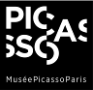

REDISCOVERING THE MEDITERRANEAN____________________________________________
EXHIBITION
The exhibition comprises 138 works by 41 artists and is articulated in six sections which are detailed in the following paragraphs.
SPAIN
Since the mid 19th century, modern Spanish painting finds in Valencia one of its greatest references. Realism implied the rise of landscape painting; motifs such as nature and activities at the beach, along with tourism and holidaying were being valued. All of which are phenomena linked to the new upcoming class, the bourgeoisie. Ignacio Pinazo is one of the first painters who, being open to innovations, is interested in the aspects of Mediterranean life focusing on both its condition as a landscape and as a stage for life. The characters, the heritage, the sea, the beach and the activities associated to it populate works painted with fast brush strokes, such as Public Holiday, On The Beach or Sea View, to name a few. Joaquín Sorolla was another painter who made the sea the object of his focus. Rocks at Jávea, The White Boat, To the Water! or Clotilde and Elena on the Rocks which captures the depth and transparency of the water in all its different colors, all celebrate the setting in which children play and women bathe. A sea full of light and joy, a natural habitat that could be identified with the description of the golden age in the Mediterranean.
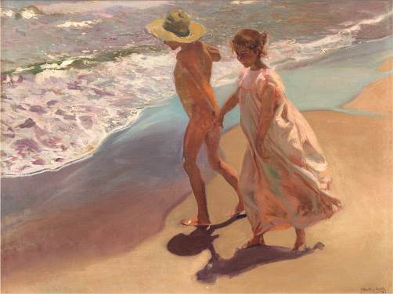
Joaquín Sorolla, To the Water, 1908
Oil on canvas, 81 x 106 cm
Colección Fundación Bancaja
Photograph: Juan García Rosell

REDISCOVERING THE MEDITERRANEAN____________________________________________
Catalonia, due to its location, is also one of the privileged locations in this rediscovery of the Mediterranean and plays a central role in the renewal of the artistic scene in Barcelona, one of the leitmotifs appearing in Eugenio d’Ors artistic essays. The writer promotes a type of classicism that finds its best representatives in Joaquim Sunyer and Joaquín Torres-García, with renown works such as Mediterranean and Pastoral, by the former, or the frescos painted by the latter in the Palau de la Generalitat de Catalunya (The Palace of the Government of Catalonia).
The female figure will be, on the other hand, a constant within Catalan painting and sculpture during these years transforming what could be anecdotal into the affirmation of a myth –soon a convention– and thus responding to what already was a tradition: the identification of women and nature.
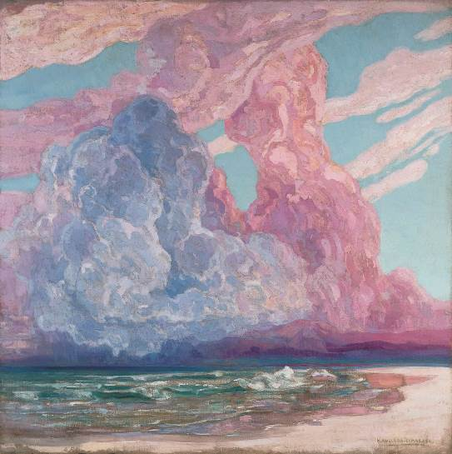
Hermen Anglada Camarasa, Storm on the Beach, c. 1925-1930
Oil on canvas. 205 x 205 cm
Colección ENAIRE
© Hermen Anglada Camarasa, VEGAP, Madrid, 2018

REDISCOVERING THE MEDITERRANEAN____________________________________________
In Majorca, another Mediterranean setting, both Joaquim Mir and Hermen Anglada Camarasa’s painting significantly changed. Mir arrived on the island for the first time in 1899 where he was fascinated by the rocky and rugged areas on the coast, the caves that make their way through the rock and their strange light that suggested a phantasmagoric and unreal appearance. In Torrent de Pareis the artist creates a cosmic, almost pantheistic world with his rendering of a landscape full of harrowing hues; a natural landscape that seems to stem from his imagination. In 1914, Anglada Camarasa settles in Port de Pollença and begins to paint Majorquin landscapes that come close to the sense of purity that characterizes Mir’s work. Renown for being one of the main drivers of modernity in Spain, with work that is half way between Symbolism and Decadent movement, Anglada produces landscapes and maritime scenes dominated by the violence of color, leading him time and again to the limits of his paintings, nearly reaching abstraction.

JULIO GONZÁLEZ
Born in Barcelona in 1876, Julio González spent most of his life in Paris working with Picasso and Gargallo, possibly with Brancusi as well, and with them he became involved with other important artists of the time such as Alberto Giacometti or Fernand Léger. Early in his career he participated in the Noucentisme movement, as is evident from the paintings Two Women and Landscape. Nevertheless, when examining his extensive trajectory as a sculptor, one cannot assert that he was a sculptor of the Noucentisme movement despite the fact a motif characteristic of the movement was ever present in his work: La Montserrat. This female figure represented the archetype of the Catalan woman, the peasant woman, Eugenio d’Ors’s La ben plantada [Firmly Rooted (woman)]. It was on the occasion of his participation at the Spanish Republic Pavillion during the 1937 Paris World Fair with La Montserrat, when González produces a number of drawings, sculptures, masks and paintings revolving around this subject.
During his Noucentista incursion, González distances himself from Torres-Garcia’s neo-Hellenic classicism and approaches, like other Spaniards such as Togores, the artistic values of 1920’s Italian artists: everyday scenarios in which three dimensional motifs, product of intense modeling, such as houses, bottles, glasses or women are central and stand out due to their volumes and mass.
In parallel, González continues with a sculptural focus in which superimposed metal sheets, which highlight volumes and empty spaces, seem to transport synthetic cubism into the realm of sculpture. A method that is recurrent in the international sculpture scene of the time. Each sheet is autonomous but when welded together they form an almost abstract sculpture that speaks of space and matter such as in Dafne, despite its clear obvious reference to a classic such as Ovid.

REDISCOVERING THE MEDITERRANEAN____________________________________________
ITALY
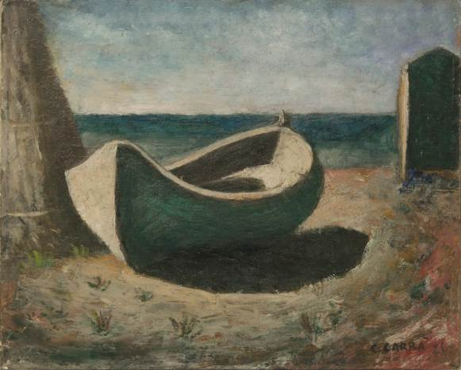
Carlo Carrà. The Boat, 1928
Oil on cardboard. 33 x 41.3 cm
Collezione Augusto e Francesca Giovanardi.
Photograph: Alvise Aspesi
© Carlo Carrà, VEGAP, Madrid, 2018

In November of 1918 the magazine Valori Plastici was launched in Rome, under the management of Mario Broglio and with the collaboration of Carlo Carrà, Giorgio de Chirico and Alberto Savinio. This publication, although not incorporating a pragmatic stance, seems to question the role of the artist in the contemporary world and underlines the crisis being suffered by European Vanguards after World War I while lending a voice to new languages that are in continuous dialogue between the retrieval of the past (and thus the retrieval of realism) and the desire to incorporate this discourse into modernity. Valori Plastici promotes in this way, a return to the ancient, to the myth and classicism, something which can be appreciated in the boats of Carrà, in the scenes of Campigli or in the muses and horses of De Chirico. All these works move along a path where time seems to have stood still and Campigli intensified this sensation through his particular technique, working the canvas in the manner of a Pompeiian fresco.

REDISCOVERING THE MEDITERRANEAN____________________________________________
Scenes that initially could seem familiar to the viewer are exhibited under the appearance of something unknown and unsettling. Imbued with melancholy, these paintings seem to speak of loss, a loss that is difficult to define describe or portray. Images of the soul that invoke the past, that invoke classicism, reminding the viewer that the happiness of the Mediterranean Arcadia will never be the same.
FRANCE
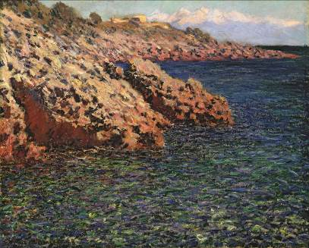
The south of France, which for a long time was a mere waypoint in the journey to Rome for artists and connoisseurs on the Grand Tour, offered a preview of Italy with its ancient monuments in Orange, Arles and Nimes. From 1880 onward, and for several decades in the 20th century, it became one of the preferred destinations for painters who were seeking out
new horizons. In Paris, the region of Provence was discovered through literature. Travelling writers who spent stints in the Midi (Southern France) all agreed in their praise of the region’s beauty, its exuberant vegetation and the wide variety of landscapes whether inland or on the coast, as well as the mild Mediterranean climate and its light. Such was the case for George Sand or Guy de Maupassant who wrote of an Eden-like natural landscape and a particular way of life and who invited their audience to see the Midi where time seemed to have come to a stand-still speaking of it as a destination where one could find new sources of inspiration.
Claude Monet
La Méditerranée, (Cap d’Antibes), 1888
Oil on canvas 65.09 x 81.28 cm
Columbus Museum of Art, Ohio. Bequest of Frederick W. Schumacher
The train line that travelled from Paris to Lyon which arrived to Marseille in 1856, Nice in 1864 and reached Ventimiglia in 1878 made travelling south easier. It was precisely in the south where a sort of open air studio was created for several generations of painters fleeing from the hardships of the urban world. This identification reached such a degree that contemporary references to the “Studios of the Midi” allow for associations between artists and the different places in which they resided: Aix-en Provence with Cézanne, Arles with Van Gogh, Antibes with Picasso, Nice with Matisse, Le Cannet with Bonnard or Cagnes-sur-Mer with Renoir.

REDISCOVERING THE MEDITERRANEAN____________________________________________
When referring to the Mediterranean, one refers to tradition; the tradition of classicism, calmness and equilibrium, order and serenity; idealized traits, models created through the passing of time. But, classicism does not necessarily refer exclusively to classical antiquity; references may allude to more primitive forces. While it might seem paradoxical, it thus also encompasses modernity, as the most modern types of work can be created in the name of the classical.
The Studios of the Midi
In the decade of 1880 and following in the footsteps of the painter Adolphe Monticelli, Van Gogh settles in Arles in his search for the “glorious sun of the Midi”. He rents a yellow house with the intention of making it a “studio in the south” for a community of artists. Although his dream did not come into fruition many painters heeded his call. Renoir, Monet, Signac, Braque, Derain Dufy, Bonnard, Matisse or Picasso went to take on the light of the Midi. They would gather every summer, inviting one another. Some only spent a few days; some would return regularly. Others like Renoir, Bonnard and Matisse ended up staying for good.
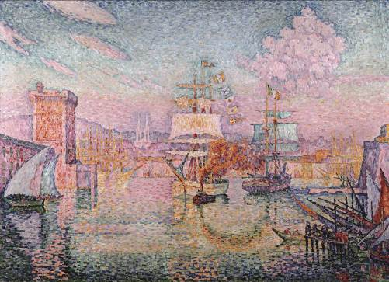
Paul Signac. L’Entrée du port de Marseille, 1911
Oil on canvas. 116.7 x 162 cm
Musée Cantini (In deposit at Musée d’Orsay)
Photograph: © Ville de Marseille, Dist. RMN-Grand Palais / Jean Bernard

Upon their arrival most artists would encounter the same problem: how to provide their works with the greatest amount of light possible? Almost all of them accomplished this goal by taking risks with colors that flooded their compositions. Monet would go on to express his woes in Antibes in 1884: “I am afraid of the tones that I must use. I fear I will be too violent and nevertheless I end up coming up short.”
REDISCOVERING THE MEDITERRANEAN____________________________________________
In 1892, after a first stay in Collioure, Signac discovered the small port of Saint-Tropez and from that moment on he spent most of the year in the area painting the landscape that surrounded him which seemed to be timeless. There he would frequently encounter his friends Henri-Edmond Cross, Théo van Rysselberghe and Louis Valtat. The first two, more akin to his aesthetic, would slowly distance themselves from Divisionism. Cross would do so in order to work on what he called “interior visions”, like Young Woman (Studio for “Clearing in the Forest”); while Van Rysselberghe would instead direct his attention towards greater technical freedom, a path on which he would coincide with Valtat, as can be observed in Piece of Flower Pot in a Garden in Provence.
In 1897, Signac bought La Hune, a villa that became a meeting point for Matisse, Camoin, Marquet, Manguin and Bonnard. None of them was a strict pointillist but they all shared the same interest in light and its relationship with color. Both Camoin and Manguin made a habit of spending lengthy periods of time in the Midi and, after their fauve periods, tempered their compositions to represent Eden-like motifs exemplified in works such as Manguin’s Cassis, The Bathroom or The Fauness, all conveying a sensation of happiness out of time.
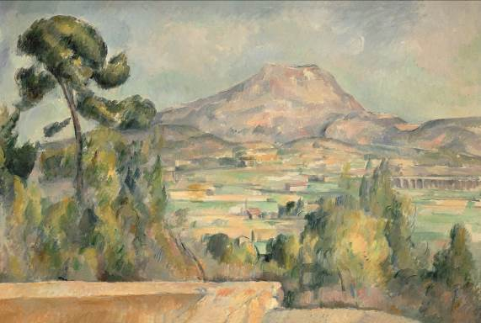
In the summer of 1905, in Collioure, Derain and Matisse began to work with pure and bright color giving birth to the fauvist adventure. A year later, Derain met with Braque and his friends Dufy and Friesz in L’estaque in order to further develop this style of painting with works such as L’Estaque or Landscape of L’Estaque by Braque being prime examples.
Paul Cézanne. La Montagne Sainte-Victoire, c.1887-1890
Oil on canvas 65 x 92 cm
Musée d’Orsay, Paris. RF 1969-30
Photograph: © RMN-Grand Palais (Musée d’Orsay)/ Hervé Lewandowski

REDISCOVERING THE MEDITERRANEAN____________________________________________
The fauvist experience did not develop to a great extent. Braque and Dufy would follow in the wake of Cézanne initiating a type of composition that would lead to Cubism. Nevertheless the use of color would endure, particularly in the work of Friesz, positioned between fauvism and neo-Cezannism, who would produce works in the classical tradition such as his nudes and pastorals, as is the case of The Bathers/The Ladies of Marseille. The issue of color was not foreign to Bonnard who, during his stay in Le Cannet, dedicated himself tirelessly to the reinterpretation of landscapes in canvases that were flooded with color and matter. Windows and terraces, which acquired increasing prominence, as in his The Sunny Terrace, were depicted as the nexus point between the public and private realms
MATISSE
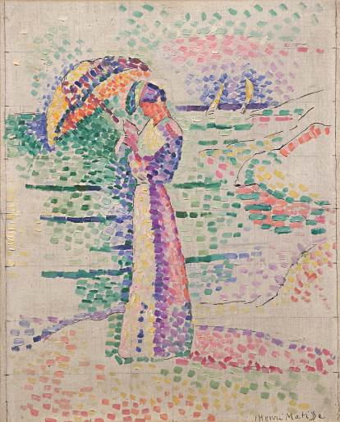
Matisse establishes himself in Saint-Tropez, along with Signac, in the summer of 1904. From this moment onward, and for a short period of time, the influence of Divisionism will become apparent in his work, as can be seen in Figure with a Parasol. The following year he arrives to Collioure, after presenting his works at the Paris Salon, where he was informally appointed as the leader of what we today know as the fauvist group. From 1907 the fauve outbreak begins to fade while works produced will be characterized by the influence of Cézanne and the showcasing of the female figure.
In 1917, Matisse travels to Nice, where four years later he would settle for the rest of his life. The monumental figures of previous years are displaced by a more intimate style of painting. From 1938, a period by which he is already living in an old palace uptown that had been reconditioned into housing, his work is dominated by the relationship between light and
Herni Matisse
Figure à l’ombrelle, Collioure, 1905
Oil on canvas 46 x 37,5 cm
Musée Matisse, Nice, Bequest of Mrs. Henri Matisse, 1960 (INV. 63.2.14)
Photograph: François Fernandez
© Succession H. Matisse, VEGAP, Madrid, 2018.

REDISCOVERING THE MEDITERRANEAN____________________________________________
pure color in collusion with the drawn line. A dialogue that he resolves with cut-outs: as if drawing with his scissors. Matisse would cut out several surfaces of previously colored paper: a technique he would use for the stained-glass windows of the Dominical Chapel in Vence, his last great work, where he manages to transform color into light and light into color.
PICASSO

Pablo Picasso
The Pigeons, 1957
Oil on canvas
100 x 81.5 cm
Museu Picasso, Barcelona
MPB 70.457
© Pablo Picasso Endowment, VEGAP, Madrid, 2018
Photograph: © Gasull Fotografia
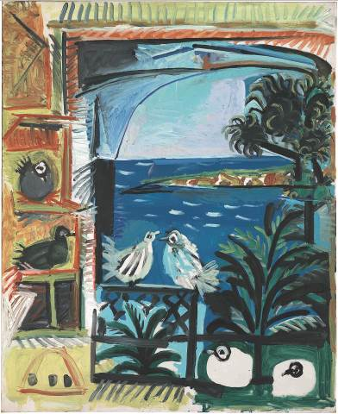
Mediterranean traditions, the light, and the vegetation of the environment all become necessary stimuli for Picasso when creating. Every summer stay in the Côte d’Azure, location to which he travels since the 1920’s and 30’s, constitutes a new scenario, and with it, a change in the motifs present in his work. Seduced by the isolation provided by the villa and the view over the bay of Cannes, Picasso purchases La Californie in 1955, a grand house/studio where he summons all the motifs that have occupied him up to that time: the representation of the studio, the painter and the model, the female figure. During this period he also works on what he calls “interior landscapes”: the motifs he observes from his window – The Pigeons – or variations within the La Californie villa derived from changes in the light that enters through the windows.

REDISCOVERING THE MEDITERRANEAN____________________________________________
In September of 1958, tired perhaps of tourist influx, Picasso moves to Château de Vauvenargues located on the foothills of mount Sainte-Victoire. After only three years, however, he relocates to Notre-Dame-de-Vie, a property on the edge of a hill in Mougins. The house becomes part of his life-story. He hangs several of his fetish works on the dining room walls as if to represent a return to his roots, his work coming full circle, with the Mediterranean as both beginning and end.

CATALOGUE
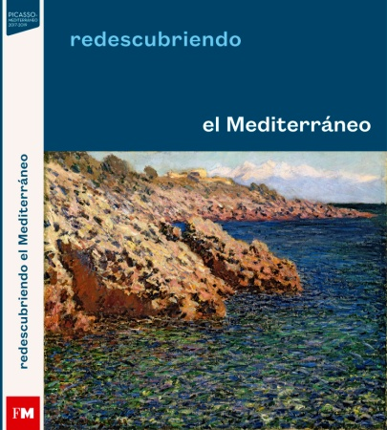
The exhibition is accompanied by a catalogue edited by Fundación MAPFRE available in Spanish including texts by the curators of the show, Mr. Pablo Jiménez Burillo and Ms. Marie-Paule Vial; Ms. Leyre Bozal, Curator for Fundación MAPFRE; Josep Casamartina I Parassols, art critic and independent curator; Daniela Ferrari, conservator and curator for the Museo di Arte Moderna e Contemporanea di Trento e Rovereto; Javier Rojas, Professor of Art History at the University of Valencia; and José Luis Alcaide Delgado.

CONFERENCE CYCLE
From the November 12th until November 22nd Fundación MAPFRE will host “Mediterranean: Classicism and Modernity” a conference cycle in which national and international experts will discuss the subject of the influence of culture and the Mediterranean sea in turn-of-the-century art.
With this cycle, as well as with the exhibition, Fundación MAPFRE aims not only to trace a path through the oeuvre of these artists but also to analyze the many ways in which the Mediterranean sea is viewed in each of the countries discuss; France, Spain and Italy, in order to discern how art opens itself up to modernity through a view of the past.

REDISCOVERING THE MEDITERRANEAN____________________________________________
PRACTICAL INFORMATION
Recoletos Exhibition Hall
Paseo de Recoletos, 23 – 28004, Madrid
Phone: 0034 915 81 61 00
TICKET PRICES
General Admission: 3€ per person
Free admission to the permanent exhibition: “Espacio Miró” with the purchase of a ticket.
In case there are no temporary exhibitions at the time, admission will be 3€ per person.
Free admission every non-holiday Monday from 2:00 pm until 8:00 pm
OPENING HOURS
Mondays from 2:00 pm until 8:00 pm
Tuesdays to Saturdays from 10:00 am until 8:00 pm
Sundays and Holidays from 11:00 am until 7:00 pm
GUIDED TOURS
Mondays at 5:30 pm
Tuesdays to Thursdays at 11:30 am, 12:30 pm, 5:30 pm and 6:30 pm.
Price: 5€
ACTIVITES, WORKSHOPS AND GAMES
Workshop Visits for Educational Institutions. Price 30€ per class.
Workshop Visits for families. Price: 3€ per family member
AUDIOGUIDE
Audio-guides (Spanish & English)
Price: 3.50 € for one exhibition, 5€ for two/three exhibitions
Sign language and Closed Captioning guides free of charge.

